NoctoPark Station
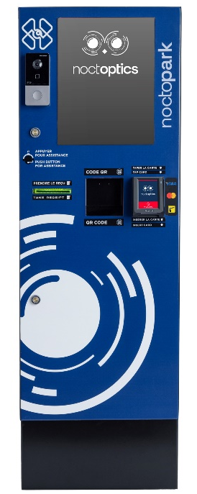

Introduction
NoctoPark parking payment station makes parking payments quick and hassle-free. Packed with advanced features and powered by our proprietary parking management software, it’s designed to deliver a seamless experience for both users and operators.

Key Features:
- Ergonomic and intuitive operation for enhanced customer experience
- 15-inch color touchscreen with guided instructions and customizable display
- Illuminated button for ticket dispensing
- Bilingual display interface (English and Arabic configurable)
- QR code printer for ticket printing (LPR Backup)
- Built to withstand harsh weather conditions for long-term reliability

Typical Application
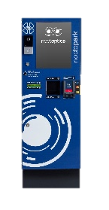
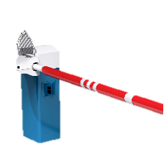


Entrance/Exit
Barrier Gate
Payment Station
Server Room/Management

Specification
General
Power Consumption | 750W (with heater off)/1050W (with heater on)
Power Supply | 120VAC
Dimension | 17.5*16*51.5 inch (W*D*H)
Working Temperature | -20°C to 60°C
Housing | Weather-proof epoxy paining
Protection | Waterproof and dust resistant (Frame)
Industrial Lock | Cam lock
Touch Screen
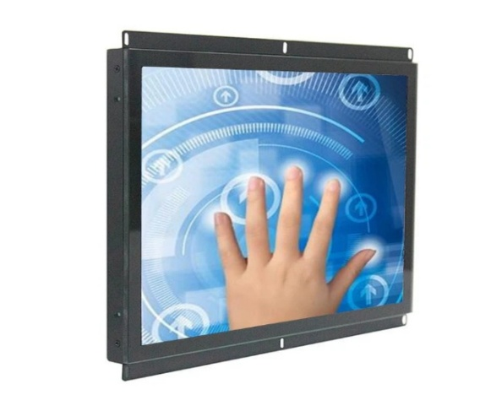

Ever Glory TFT LCD Monitor
ZD-150MT3C-V23
Resolution | 1024(H)×768(V)
Dimension | 15 inch
Angle | 80/80/80/80 (L/R/U/D)
Color | 16.7M／262K
Brightness | 950cd/m2
Contrast Ratio | 600:1
Backlight | LED
Display Size | 304.128(H)×228.096(V)mm
Response Time | 8ms
Transmittance | >95%
Interface | VGA, HDMI, DC, PCAUDIO
Surface Hardness | 7H
IP Ingress Protection | IP65 (front panel)
Code Scanner
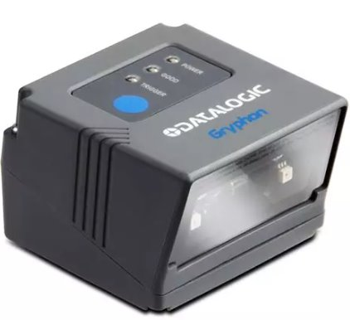

DATALOGIC Code Scanner
Light Source | 650 nm visible laser diode
Pitch | ±40 degree
Roll | ±180 degree
Yaw | ±40 degree
Decoding Capability | 1D / Linear Codes: Autodiscriminates all standard 1D codes including GS1 Data Bar linear codes  2D Codes:  - Aztec Code  - China Han Xin Code  - Data Matrix  - Maxi Code  - Micro QR Code  - QR Code  Postal Codes:  - Australian Post  - British Post  - China Post  - IMB  - Japanese Post  - KIX Post  - Korea Post  - Planet Code  - Postnet  - Royal Mail Code (RM4SCC)  Stacked Codes:  - EAN/JAN Composites  - GS1 DataBar Composites  - GS1 DataBar Expanded Stacked  - GS1 DataBar Stacked  - GS1 DataBar Stacked Omnidirectional  - MacroPDF  - MicroPDF417  - PDF417  - UPC A/E Composites
Features | Highly visible 4-Dot aimer with center-cross for targeted scanning  Omnidirectional reading  Advanced motion tolerance optics  Image capture and document scanning capabilities  Reads bar codes down to 4mils  Reads 1D, 2D and postal codes plus stacked and composite codes  Datalogic's Green Spot for good-read feedback  Integrated good-read beeper  High-impact resin creates a solvent-tolerant enclosure
IP Ingress Protection | IP54
Receipt Printer
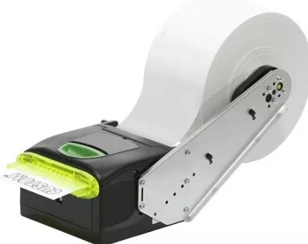

Custom VKP80III Receipt Printer

Flash | 4 megabyte
RAM | 16 kilobyte
Interface | Serial, USB
Max B/W Print Resolution | 203 dpi
Max H-Document Size | 3.25 in
Max Media Weight | 110 gram per square metre
Max Mono Print Speed | 519.7 Inches per minute
Max Print Size | Roll (3.25 in)
Max Roll Diameter | 11.8 inch
Min H-Document Size | 2.35 in
Min Media Weight | 55 gram per square metre
Print Output Type | Monochrome
Print Speed | Up to 519.7 inch/min - max speed
Barcode Symbology Supported | PDF417, QR code
Media Feeders | 1 x manual - 1 roll - Roll (3.25 in)
Media Sizes | Roll (3.25 in)
Auto Paper Cutter | Yes
Media Type | Thermal paper
Mini PC
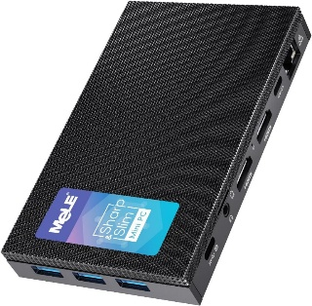

MeLE Mini PC
CPU | Intel Celeron 11th Gen Jasper Lake N5105, Quad cores, Frequency 2.00 GHz-2.90 GHz
GPU | Intel UHD Graphics(Graphics Frequency 450 MHz-800MHz)
Operating System | OS-P
Memory | LPDDR4 8GB
Storage | 256GB eMMC On board
Wireless Connectivity | Bluetooth 5.1, WiFi (802.11ac) 2.4GHz/5GHz
Ethernet | 1000Mbps LAN
Video Output | 2x HDMI® 2.0 (4K@60Hz), 1x USB Type-C (4K@60Hz)
Audio Output | 3.5mm Audio Combo Jack
USB | 3x USB 3.0, 1x USB Type-C
Modicon
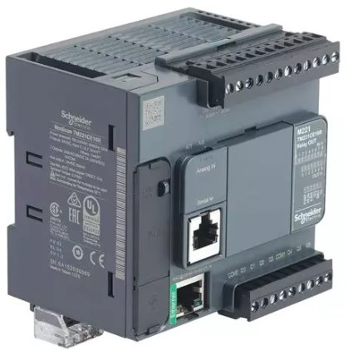

Schneider Electric Modicon
Range of Product | Modicon M221
Discrete Input Number | 9, discrete input IEC 61131-2 Type 1
Analogue Input Number | 2 0...10 V
Discrete Output Type | Relay normally open
Discrete Output Number | 7 relay
Discrete Output Voltage | 5...125 V DC  5...250 V AC
Discrete Output Current | 2 A
Discrete I/O Number | 16
Maximum Number of I/O Expansion Module | 4 local  11 remote
Supply Voltage Limits | 85…264 V
Network Frequency | 50/60 Hz
Inrush Current | 40 A
Maximum Power Consumption in VA | 49 VA 100...240 V with max number of I/O expansion module  33 VA 100...240 V without I/O expansion module
Power Supply Output Current | 0.325 A 5 V expansion bus  0.12 A 24 V expansion bus
Discrete Input Logic | Sink or source (positive/negative)
Discrete Input Voltage | 24 V
Discrete Input voltage type | DC
Analogue Input Resolution | 10 bits
LSB Value | 10 mV
Conversion Time | 1 ms per channel + 1 controller cycle time analog input
Permitted Overload on Inputs | +/- 30 V DC 5 min maximum)analog input  +/- 13 V DC permanent)analog input
Voltage State 1 Guaranteed | >= 15 V input
Voltage State 0 Guaranteed | <= 5 V input
Discrete Input Current | 7 mA discrete input  5 mA fast input
Input Impedance | 3.4 kOhm discrete input  100 kOhm analog input  4.9 kOhm fast input
Response Time | 35 µs turn-off, I2...I5 input  10 ms turn-on output  10 ms turn-off output  5 µs turn-on, I0, I1, I6, I7 fast input  35 µs turn-on, other terminals input  5 µs turn-off, I0, I1, I6, I7 fast input  100 µs turn-off, other terminals input
Configurable Filtering Time | 0 ms input  3 ms input  12 ms input
Output Voltage Limits | 125 V DC  277 V AC
Maximum  Current per Output Common | 6 A COM 1  7 A COM 0
Absolute Accuracy Error | +/- 1 % of full scale analog input
Electrical Durability | 100000 cycles AC-12, 120 V, 240 VA, resistive  100000 cycles AC-12, 240 V, 480 VA, resistive  300000 cycles AC-12, 120 V, 80 VA, resistive  300000 cycles AC-12, 240 V, 160 VA, resistive  100000 cycles AC-15, cos phi = 0.35, 120 V, 60 VA, inductive  100000 cycles AC-15, cos phi = 0.35, 240 V, 120 VA, inductive  300000 cycles AC-15, cos phi = 0.35, 120 V, 18 VA, inductive  300000 cycles AC-15, cos phi = 0.35, 240 V, 36 VA, inductive  100000 cycles AC-14, cos phi = 0.7, 120 V, 120 VA, inductive  100000 cycles AC-14, cos phi = 0.7, 240 V, 240 VA, inductive  300000 cycles AC-14, cos phi = 0.7, 120 V, 36 VA, inductive  300000 cycles AC-14, cos phi = 0.7, 240 V, 72 VA, inductive  100000 cycles DC-12, 24 V, 48 W, resistive  300000 cycles DC-12, 24 V, 16 W, resistive  100000 cycles DC-13, 24 V, 24 W, inductive (L/R = 7 ms)  300000 cycles DC-13, 24 V, 7.2 W, inductive (L/R = 7 ms)
Switching Frequency | 20 switching operations/minute with maximum load
Mechanical Durability | 20000000 cycles relay output
Minimum Load | 1 mA 5 V DC relay output
Protection Type | Without protection 5 A
Reset Time | 1 s
Memory Capacity | 256 kB user application and data RAM 10000 instructions  256 kB internal variables RAM
Data Backed Up | 256 kB built-in flash memory backup of application and data
Battery Type | BR2032 or CR2032X lithium non-rechargeable
Backup Time | 1 year 77 °F (25 °C) by interruption of power supply)
Execution Time for 1 KInstruction | 0.3 ms event and periodic task
Execution Time per Instruction | 0.2 µs Boolean
Exct Time for Event Task | 60 µs response time
Maximum Size of Object Areas | 255 %C counters  512 %KW constant words  255 %TM timers  512 %M memory bits  8000 %MW memory words
Realtime Clock | With
Clock Drift | <= 30 s/month 77 °F (25 °C)
Regulation Loop | Adjustable PID regulator up to 14 simultaneous loops
Counting Input Number | 4 fast input (HSC mode) 100 kHz 32 bits
Counter Function | Pulse/direction  A/B  Single phase
Integrated Connection Type | USB port mini B USB 2.0  Non isolated serial link serial 1 RJ45 RS232/RS485  Ethernet RJ45
Supply | Serial)serial link supply 5 V, <200 mA
Transmission Rate | 1.2...115.2 kbit/s (115.2 kbit/s by default) 49.2 ft (15 m) RS485  1.2...115.2 kbit/s (115.2 kbit/s by default) 9.8 ft (3 m) RS232  480 Mbit/s USB
Communication Port Protocol | USB port USB - SoMachine-Network  Non isolated serial link Modbus master/slave - RTU/ASCII or SoMachine-Network  Ethernet
Port Ethernet | 10BASE-T/100BASE-TX 1 328.08 ft (100 m) copper cable
Communication Service | DHCP client  Ethernet/IP adapter  Modbus TCP server  Modbus TCP slave device  Modbus TCP client
Insulation | Between input and internal logic 500 V AC  Non-insulated between analogue input and internal logic  Non-insulated between analogue inputs  Between supply and ground 1500 V AC  Between sensor power supply and ground 500 V AC  Between input and ground 500 V AC  Between output and ground 1500 V AC  Between supply and internal logic 2300 V AC  Between sensor power supply and internal logic 500 V AC  Between output and internal logic 2300 V AC  Between Ethernet terminal and internal logic 500 V AC  Between supply and sensor power supply 2300 V AC
Marking | CE
Standards | IEC 61131-2  UL 508  CAN/CSA C22.2 No. 213  IACS E10  ANSI/ISA 12-12-01
Certifications | cULus  LR  RCM  EAC  ABS  DNV-GL  CE  UKCA  cULus HazLoc
Resistance to Electrostatic Discharge | 8 kV in air IEC 61000-4-2  4 kV on contact IEC 61000-4-2
Resistance to Magnetic Fields | 98.4 A/ft (30 A/m) 50/60 Hz IEC 61000-4-8
Resistance to Fast Transients | 2 kV IEC 61000-4-4 power lines)  2 kV IEC 61000-4-4 relay output)  1 kV IEC 61000-4-4 I/O)  1 kV IEC 61000-4-4 Ethernet line)  1 kV IEC 61000-4-4 serial link)
Surge Withstand | 2 kV power lines (AC) common mode IEC 61000-4-5  2 kV relay output common mode IEC 61000-4-5  1 kV I/O common mode IEC 61000-4-5  1 kV shielded cable common mode IEC 61000-4-5  0.5 kV power lines (DC) differential mode IEC 61000-4-5  1 kV power lines (AC) differential mode IEC 61000-4-5  1 kV relay output differential mode IEC 61000-4-5  0.5 kV power lines (DC) common mode IEC 61000-4-5
Resistance to Conducted Disturbances | 10 V 0.15...80 MHz IEC 61000-4-6  3 V 0.1...80 MHz Marine specification (LR, ABS, DNV, GL)  10 V spot frequency (2, 3, 4, 6.2, 8.2, 12.6, 16.5, 18.8, 22, 25 MHz) Marine specification (LR, ABS, DNV, GL)
Electromagnetic Emission | Conducted emissions 79 dBμV/m QP/66 dBμV/m AV power lines (AC))0.15…0.5 MHz IEC 55011  Conducted emissions 73 dBμV/m QP/60 dBμV/m AV power lines (AC))0.5…300 MHz IEC 55011  Conducted emissions 120...69 dBµV/m QP power lines)10…150 kHz IEC 55011  Conducted emissions 63 dBμV/m QP power lines)1.5…30 MHz IEC 55011  Radiated emissions 40 dBμV/m QP class A 10 m)30…230 MHz IEC 55011  Conducted emissions 79...63 dBμV/m QP power lines)150…1500 kHz IEC 55011  Radiated emissions 47 dBμV/m QP class A 10 m)200…1000 MHz IEC 55011
Immunity to Microbreaks | 10 ms
IP Degree of Protection | IP20 with protective cover in place
Network Switch
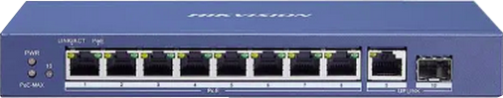
Hikvision Smart Network Switch
Ports | 8 × Gigabit PoE port,1 × Gigabit RJ45 port,1 × Gigabit fiber optical port
MAC Address Table | 4 K
Switching Capacity | 20 Gbps
Packet Forwarding Rate | 14.88 Mpps
Internal Cache | 1.5 Mbits
PoE Standard | IEEE 802.3af,IEEE 802.3at
PoE Port | PoE: Ports 1 to 8
Max. Port Power | 30 W
EMC | FCC (47 CFR Part 15, Subpart B),CE-EMC (EN 55032: 2015+A11: 2020, EN IEC 61000-3-2: 2019, EN 61000-3-3: 2013+A1: 2019, EN 50130-4: 2011+A1: 2014, EN 55035: 2017+A11: 2020),IC (ICES-003: Issue 7:2020),RCM (AS/NZS CISPR 32: 2015)
Safety | UL (UL 60950-1),CB (AMD1:2009, AMD2:2013, IEC 62368-1: 2014 (Second Edition), CE-LVD (EN 62368-1: 2014+A11: 2017)
USB Hub
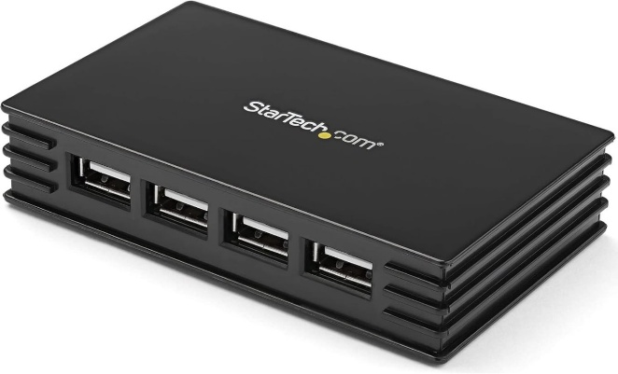

StarTech USB Hub with Power
Hardware Interface | USB 2.0
Additional Features | Powered
Total Usb Ports | 7
Data Transfer Rate | 480 Megabits Per Second
Operating System | OS Independent; No additional drivers or software required
Colour | Black
Enclosure Material | Plastic
Item Dimensions L x W x H | 9.9L x 6.1W x 2H Centimetres
Item Weight | 0.17 Pounds

Dimension
